Taxpayers cannot keep funds in traditional IRAs indefinitely. A taxpayer must generally start receiving distributions from their IRAs by April 1 of the year following the year in which they reach age 70 1/2. The taxpayer must receive at least a minimum amount for each year starting with the year they reach age 70 1/2. If they don’t receive the minimum distribution in the year they reach 70 1/2 they have until April 1, of the following year to take the distribution for the year they reached 70 1/2. In this case, you would be required to take two minimum distributions for that year. This only applies to the first year.
The IRA administrator normally calculates the RMD for the taxpayer, but it is the taxpayer’s responsibility to take the RMD. The penalty for not taking the RMD by the due date is 50% of the shortfall. For taxpayers with multiple IRAs the RMD is based on the total of all their IRAs, but it can be taken from any of them.
Waiver of tax. The IRS can waive part or all of this penalty if the TP can show that any shortfall in the amount of distributions was due to reasonable error, and they are taking reasonable steps to remedy the shortfall. If you believe you qualify for this relief, attach a statement of explanation and file Form 5329.The IRS will review the information you provide and decide whether to grant your request for a waiver
As AARP Tax-Aide preparers, our responsibility is to ask each taxpayer that has reached 70 1/2 in the current tax year and has IRA(s) if they took their minimum distribution. If they are uncertain, they should contact their plan administrator(s) to determine what their RMD is.
If taxpayer has failed to take RMD from a qualified retirement plan, then they need to include Form 5329 (Additional Taxes on Qualified Plans (Including IRAs) and Other Tax-Favored Accounts) to deal with the penalty. TSO will calculate the penalty based on the information in form 5329. If they would like to apply for a waiver:
Step 1 - In TSO open form 5329 (Use the search box)
Step 2 - Scroll down to Part IX
Step 3 - Enter the RMD amount
Step 4 - Enter the actual amount that was distributed from the IRAs
Step 5 - Check the box “Check here to claim a waiver on your additional tax for failure to take a Required Minimum Distribution”
Step 6 – Enter the waiver amount (usually the difference between the RMD and the actual distribution)
Step 7 - Complete the Explanation for Waiver. There is not much room to type the explanation. Keep it short.
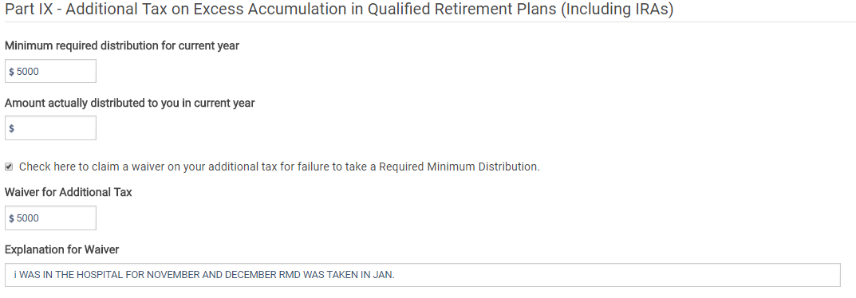
Step 7
Step 6
Step 5
Step 4
Step 3

Step 8 - Print the PDF of the 5329
Step 9 - Check the following:
  - There is no penalty amount on 1040 Schedule 4 line 59
  - The 5329 Part IX and explanation is included in the return and looks like below:
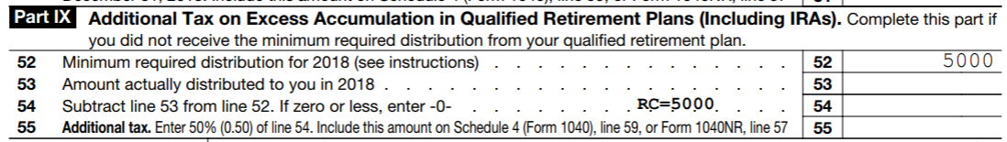

  - The explanation is on a separate page.
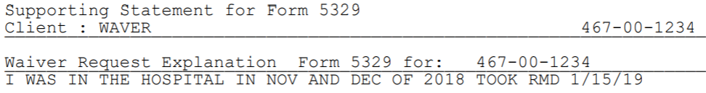

Required Minimum Distribution Tips
- Alert taxpayers that are approaching 70 1/2 and have IRAs that they will be required to take RMD distributions and they should contact their plan administrator(s) for the amounts.
- If a taxpayer missed taking a RMD due to a misunderstanding or unintentional error, help them rectify the situation and apply for the waver using the process above.
- Form 5329 is specific to an individual. Complete Form 5329 with TP or SP information, as appropriate.

